**Cursors**

**Scenario 1:**

DECLARE

  CURSOR txn_cur IS

    SELECT t.TransactionID, t.AccountID, t.Amount, t.TransactionDate, t.TransactionType, c.Name

    FROM Transactions t

    JOIN Accounts a ON t.AccountID = a.AccountID

    JOIN Customers c ON a.CustomerID = c.CustomerID

    WHERE TRUNC(t.TransactionDate, 'MM') = TRUNC(SYSDATE, 'MM');

  txn_rec txn_cur%ROWTYPE;

BEGIN

  OPEN txn_cur;

  LOOP

    FETCH txn_cur INTO txn_rec;

    EXIT WHEN txn_cur%NOTFOUND;

    DBMS_OUTPUT.PUT_LINE('Statement → Customer: ' || txn_rec.Name ||

                         ' | Account ID: ' || txn_rec.AccountID ||

                         ' | ' || txn_rec.TransactionType ||

                         ' ₹' || txn_rec.Amount ||

                         ' on ' || TO_CHAR(txn_rec.TransactionDate, 'DD-Mon-YYYY'));

  END LOOP;

  CLOSE txn_cur;

END;

/

**Output:**

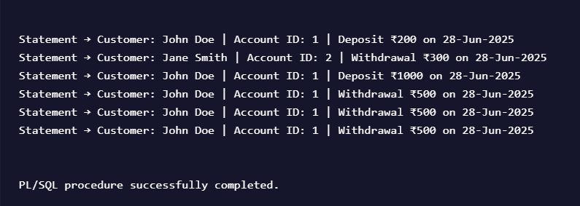

**Scenario 2:**

DECLARE

  CURSOR acc_cur IS

    SELECT AccountID FROM Accounts;

  acc_rec acc_cur%ROWTYPE;

BEGIN

  OPEN acc_cur;

  LOOP

    FETCH acc_cur INTO acc_rec;

    EXIT WHEN acc_cur%NOTFOUND;

    UPDATE Accounts

    SET Balance = Balance - 200

    WHERE AccountID = acc_rec.AccountID;

    DBMS_OUTPUT.PUT_LINE('Annual fee deducted from Account ID: ' || acc_rec.AccountID);

  END LOOP;

  CLOSE acc_cur;

  COMMIT;

END;

/

**Output:**

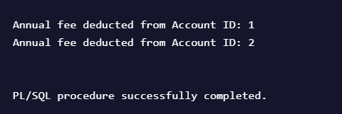

**Scenario 3:**

DECLARE

  CURSOR loan_cur IS

    SELECT LoanID, InterestRate FROM Loans;

  loan_rec loan_cur%ROWTYPE;

BEGIN

  OPEN loan_cur;

  LOOP

    FETCH loan_cur INTO loan_rec;

    EXIT WHEN loan_cur%NOTFOUND;

    UPDATE Loans

    SET InterestRate = loan_rec.InterestRate + 0.5

    WHERE LoanID = loan_rec.LoanID;

    DBMS_OUTPUT.PUT_LINE('Interest updated for Loan ID: ' || loan_rec.LoanID);

  END LOOP;

  CLOSE loan_cur;

  COMMIT;

END;

/

**Output:**

